

Department of Mathematics and Natural Sciences
Physics -112 Lab Assignment: 01

Resources:
Link for online lab:
https://phet.colorado.edu/sims/html/coulombs-law/latest/coulombs-law_all.html
List and link for the graph-plotting softwares:
● Desmos (Online): Desmos | Let's learn together.
● Graph (Offline): Download | Graph (padowan.dk)

Tutorials:
● Tutorial link for plotting in Desmos :
https://www.youtube.com/watch?v=-lIUNWVKnUY
● Tutorials link for the Graph :
How to install graph software:
https://youtu.be/e19JqLJMx3A
How to draw a curve using graph software:
https://youtu.be/QBkdzU_8vVo
How to calculate the slope of a line using graph software:
https://youtu.be/z4cMiUFu5j8

Tasks:
This activity consists of two Parts:
- Part one: Electric force versus distance.
- Part two: Electric forces versus charge.

Objectives:
- Satisfy Coulomb’s law experimentally
- Study the parameters that affect the electric force (distance and charge).
- Find experimentally the electric constant k.

Theoretical Background:
Coulomb’s Law: “The magnitude of the electric force that a particle exerts on another is directly proportional to the product of their charges and inversely proportional to the square of the distance between them.” Mathematically, the magnitude of this electrostatic force F_{E} acting on two charged particles (q₁, q₂) is expressed as:
F_{E} = kq₁q₂/r²
Where r is the separation distance between the charged objects and k is a constant of proportionality, called the Coulomb constant, k = 9.0 × 10⁹ Nm²/C².

Part one:
To satisfy the objectives do the following steps.
- Click on the following link and fix the charge q₁ and q₂ write their values in table.1.
https://phet.colorado.edu/sims/html/coulombs-law/latest/coulombs-law_en.html
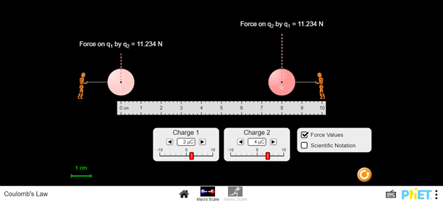
- Change the distance between the two charges as shown in the table.
- Record the force value for each distance.
- Fill table 1 by finding r² and 1/r².
Table.1 : Data of Force between two charges.
q₁=……$2µC$……. |  | q₂=……$4µC$…….
r (cm) | r² (m²) | 1/r² (1/m²) | F_{E} (N)
10 | 0.01 | 100 | 7.190
9 | 0.0081 | 123.46 | 8.877
8 | 0.0064 | 156.25 | 11.234
7 | 0.0049 | 204.08 | 14.674
6 | 0.0036 | 277.78 | 19.972
5 | 0.0025 | 400 | 28.760
4 | 0.0016 | 625 | 44.938
3 | 0.0009 | 1111.11 | 79.889

Part two:
To satisfy the objectives do the following steps.

- Click on the following link and fix the charge q₁ and the distance r, write their values in the table https://phet.colorado.edu/sims/html/coulombs-law/latest/coulombs-law_en.html
- Control q₁ and fix it at 5$µ$c and fix the distance between the two objects at 6 cm, record them in table 2.
- Change the charge of object 2 as shown in table.2 and for each q₂ record the electric force between the two objects in table 2.
Table.2 : Data for electric force for different charges.
q₁ = 5 $µC$ | r = 6 cm
q₂ ($µC$) | F_{E} (N)
10 | 124.827
9 | 112.344
8 | 99.862
7 | 87.379
6 | 74.896
5 | 62.414
4 | 49.931
3 | 37.448

Calculations and Analysis:

Part one:

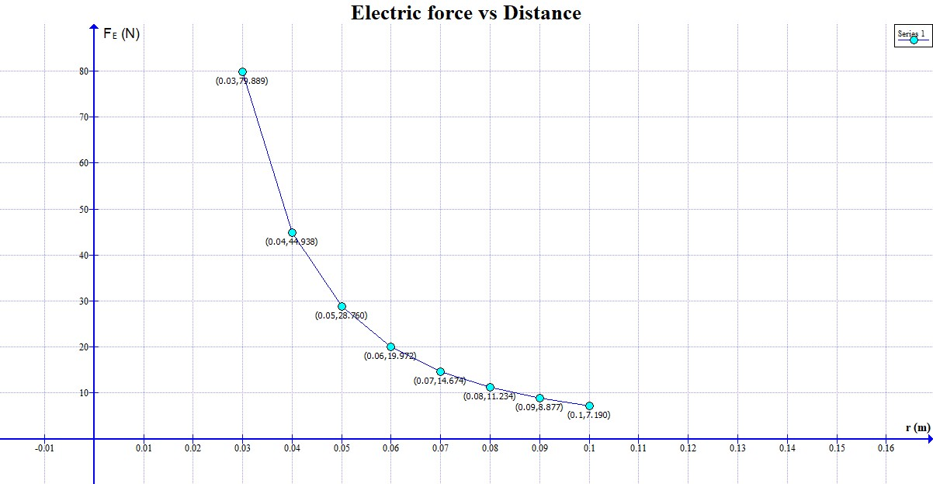
- Plot a graph relating F_{E} and r. comment on the graph.

The graph shows an exponential curve. As the distance between the charges decreases, the repulsive force between them increases exponentially.

- Plot one more graph relating F_{E} and 1/r². Use the graph to find the electric constant k.

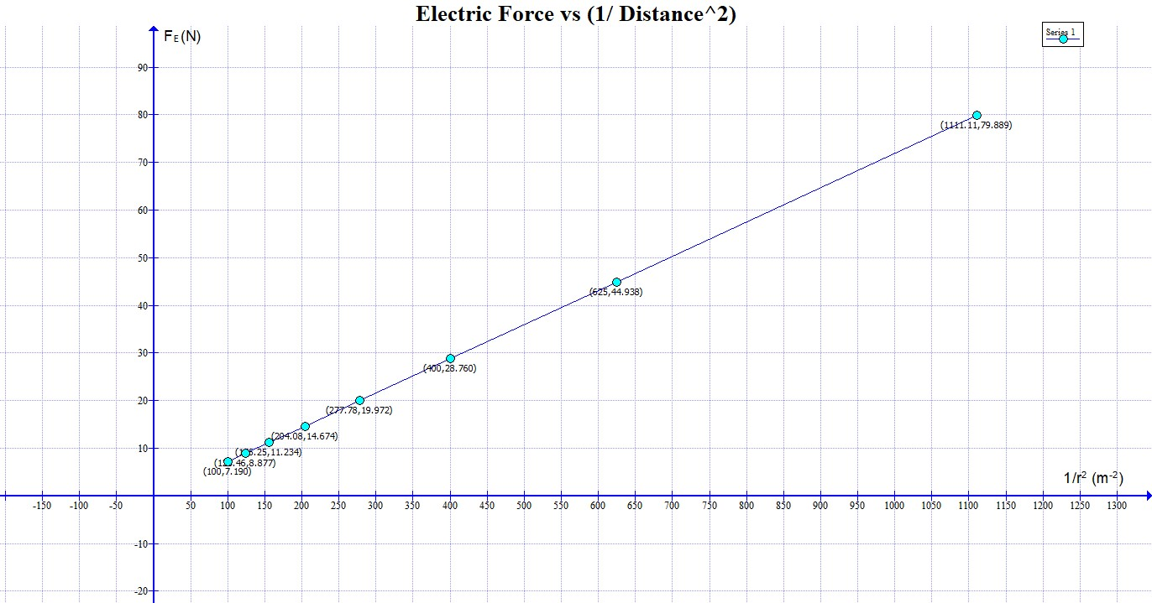

As we can see in the graph, the slope(m) equals 0.071899, which corresponds to kq₁q₂. If we divide the slope with q₁q₂ (which are respectively 2$µC$ and 4$µC)$, we get the electric constant k = 8.987375 x 10⁹ Nm²/C²

- Calculate the percentage error in k (k_{known}=9.0 × 10⁹ Nm²/C²)

- Percentage of error = ((8.987375 x 10⁹ - 9.0 × 10⁹) / 9 x 10⁹) x 100%
= 0.14%

Note: upload graph using google form

Part two:
- Plot a graph relating F_{E} and q₂. comments on the graph.

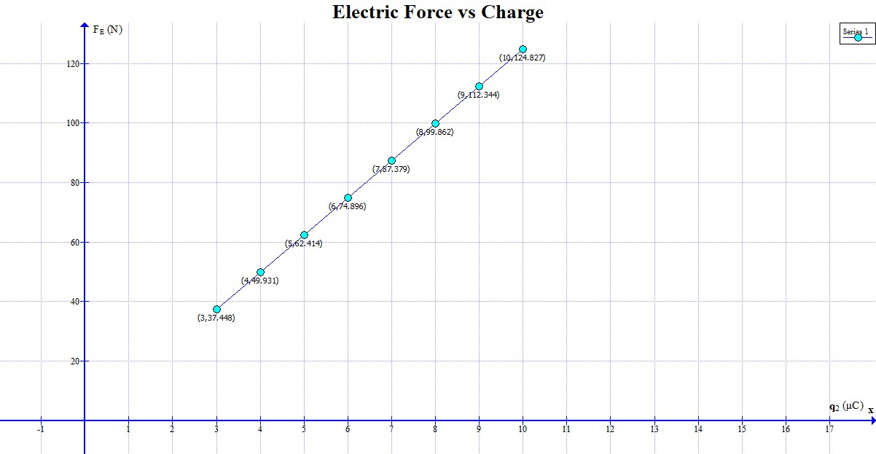

The graph shows a linear relationship between electric force and charge. As the charge (q₂) increases, the electric force (F_{E}) increases proportionally. This indicates that the electric force is directly proportional to the charge, following a linear trend.

- Use the graph to find the electric constant k.

- According to the graph, we found out that the slope(m’) is 1.2483 x 10⁷ in SI unit which is equal to kq₁/r². So, if we calculate, we get the electric constant k = 8.987799 x 10⁹ Nm²/C²

- Calculate the percentage error in k (k_{known}=9.0 × 10⁹ Nm²/C²)

- Percentage of error = ((8.987799 x 10⁹ - 9.0 × 10⁹) / 9 x 10⁹) x 100%
= 0.13556%

Note: upload graph using google form

